Summer Trend- The Jumpsuit
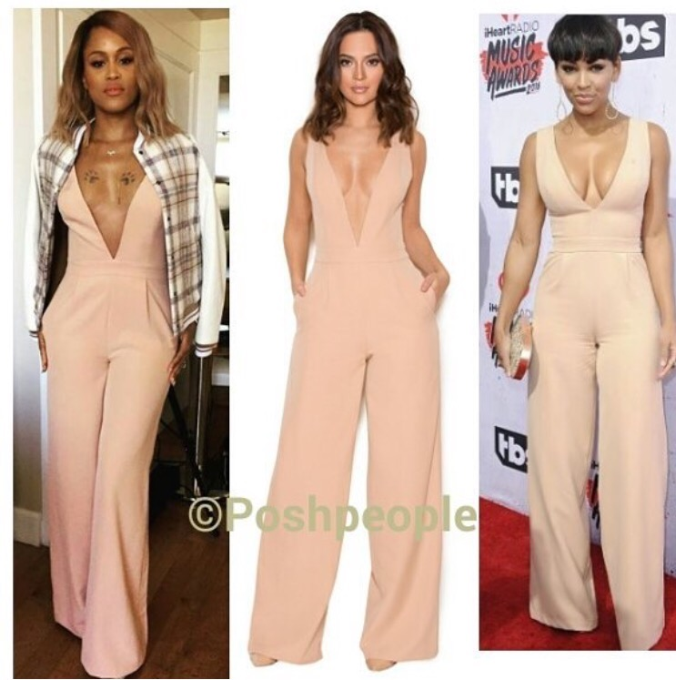
Photo Credit: www.instagram.com / www.houseofcb.com
Have you updated your wardrobe with the latest trend, the jumpsuit? This summer is definitely the season for you to add this piece to your closet. It is very easy to wear, and is a great pick for any occasion.
If you’re looking for a casual jumpsuit to hang out in or run some errands, this look is perfect for you. This distressed button up denim jumpsuit is cute and casual for a day time look.

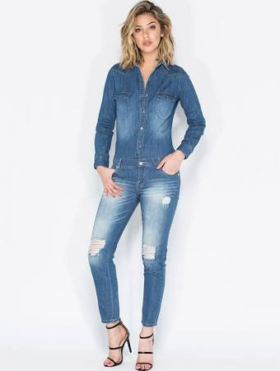
$52.00
www.gojane.com

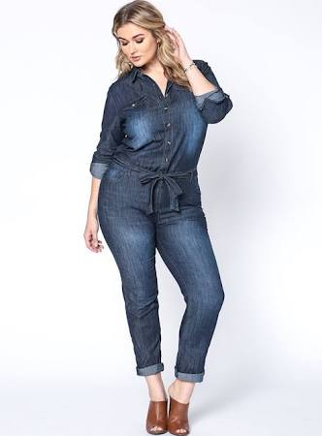
$49.95
www.debshops.com

So you and the girls want to go out and hit the town, this sleeveless jumpsuit is a good choice for the party girl. This jumpsuit has a v- neck cut in the front with an exposed back, that gives a hint of sexy to this look.

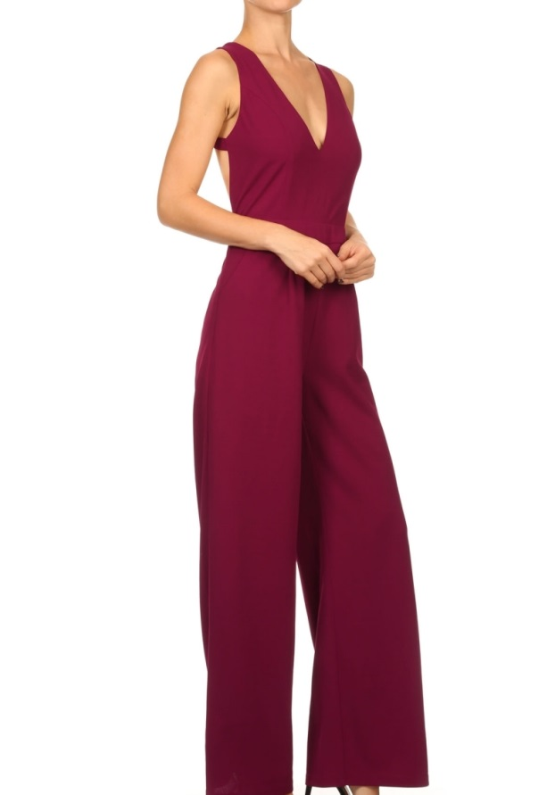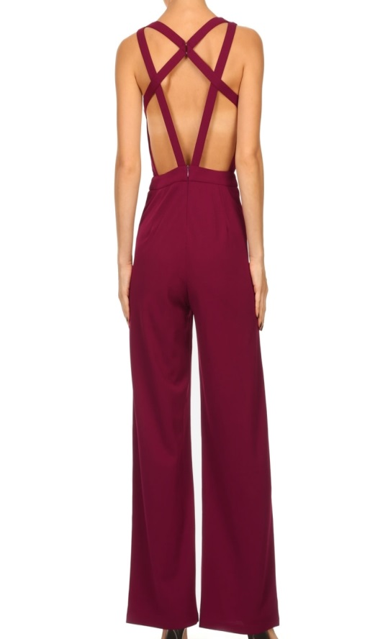
$32.99
www.theposhpeople.com

For the fashionista that is a little daring, and doesn’t mind showing some skin, this look is for you. Skin is definitely in and if you are bold enough check out this black jumpsuit with embellishments.

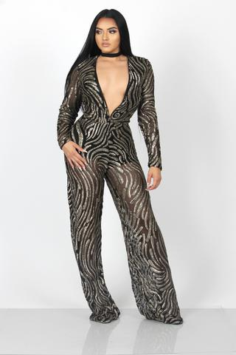
$203.00
www.intertwinecollection.com

For my curvy girls if you’re in need of a jumpsuit, asos is the perfect place to look. We selected this cute blue jumpsuit with lace detail, with a belt for the woman our divas with curves. The belted waist is perfect for accentuating your body in the right places.
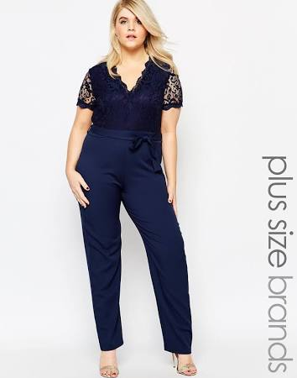
$46.00
www.asos.com

Written By: Tiffany Greene
Fashion Writer/ Wardrobe Stylist
www.theposhpeople.com

